Carnage

Aim:

To analyze a malicious packet capture (PCAP) using Wireshark and identify infection behavior, command-and-control (C2) communication, and post-infection activity.

Scenario

Eric Fischer from the Purchasing Department at Bartell Ltd has received an email from a known contact with a Word document attachment. Upon opening the document, he accidentally clicked on “Enable Content.” The SOC Department immediately received an alert from the endpoint agent that Eric’s workstation was making suspicious connections outbound. The pcap was retrieved from the network sensor and handed to you for analysis.

Task: Investigate the packet capture and uncover the malicious activities.

*Credit goes to Brad Duncan for capturing the traffic and sharing the pcap packet capture with InfoSec community.

NOTE: DO NOT directly interact with any domains and IP addresses in this challenge.

Deploy the machine attached to this task; it will be visible in the split-screen view once it is ready.

If you don’t see a virtual machine load, then click the Show Split View button. Press enter or click to view image in full size

This image and all the theoretical content of the present article is TryHackMe´s property.

Answer the question below

  - Read the above. No answer needed

Traffic Analysis

Press enter or click to view image in full size

This image and all the theoretical content of the present article is TryHackMe´s property.

Are you ready for the journey?

Please, load the pcap file in your Analysis folder on the Desktop into Wireshark to answer the questions below.

Answer the questions below

  - What was the date and time for the first HTTP connection to the malicious IP? (answer format: yyyy-mm-dd hh:mm:ss)
2021-09-24 16:44:38

Configured date and time format.
Clicked Edit > Preferences > Columns > Time > UTC date, as YYYY-MM-DD, and time > OK.
Press enter or click to view image in full size
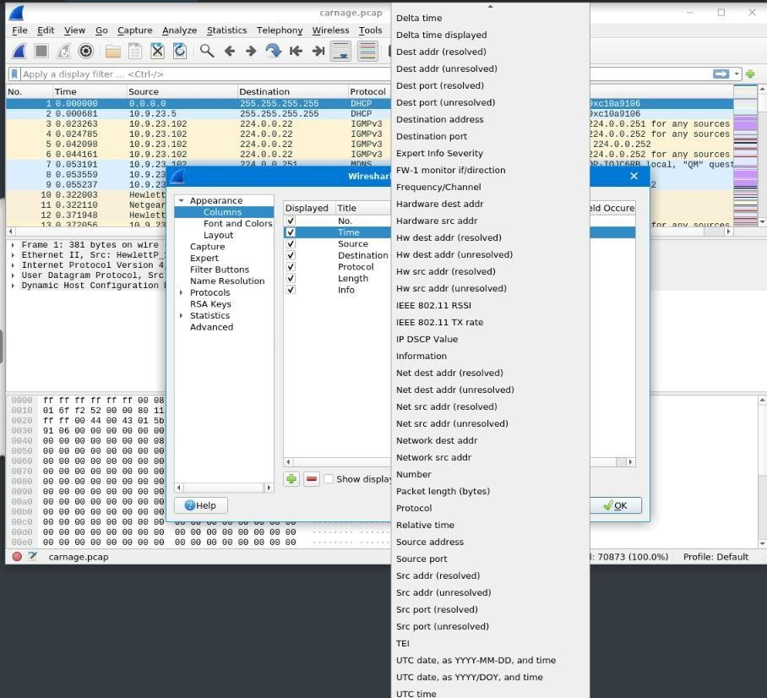
Press enter or click to view image in full size
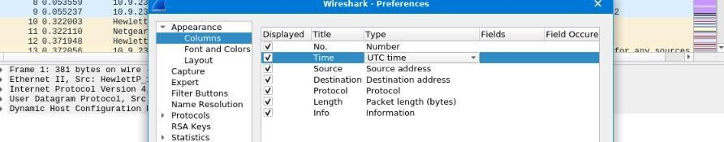

Applied filter http.

Press enter or click to view image in full size

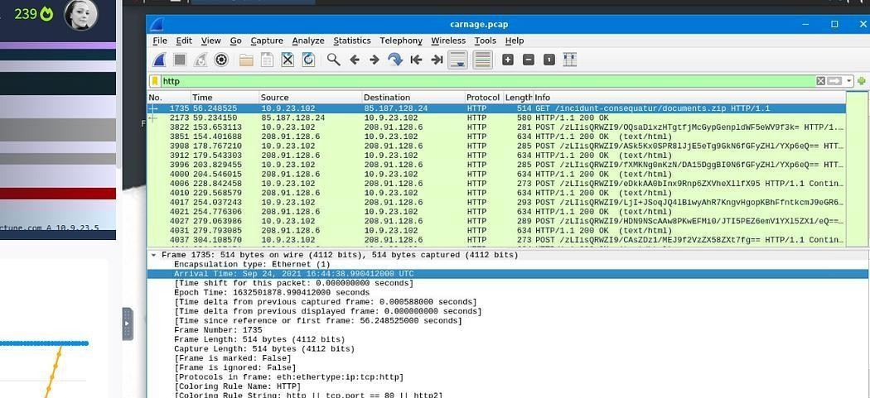

  - What is the name of the zip file that was downloaded?
documents.zip

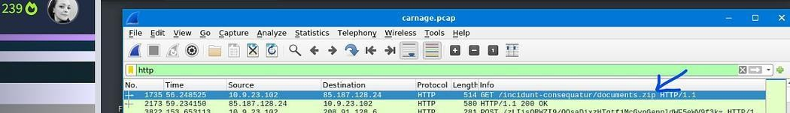
Got the answer in the frame analyzed in 2.1. Press enter or click to view image in full size

  - What was the domain hosting the malicious zip file?
attirenepal.com

Got the answer in the frame analyzed in 2.1: clicked over the frame and then over Hyper Text Transfer Protocol.
Press enter or click to view image in full size
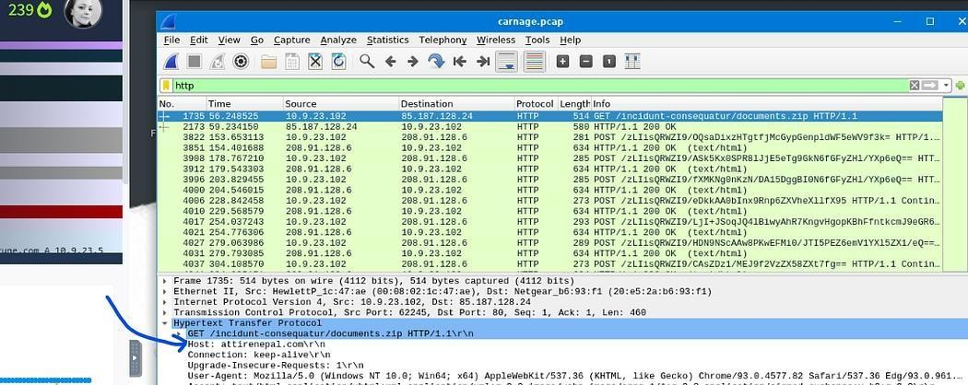

  - Without downloading the file, what is the name of the file in the zip file?
chart-1530076591.txt

Got the answer in the frame analyzed in 2.1: right-clicked over the frame, selected Follow, selected TCP Stream.
Press enter or click to view image in full size
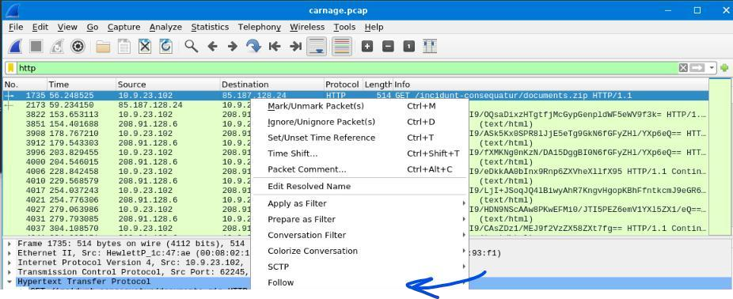
Press enter or click to view image in full size
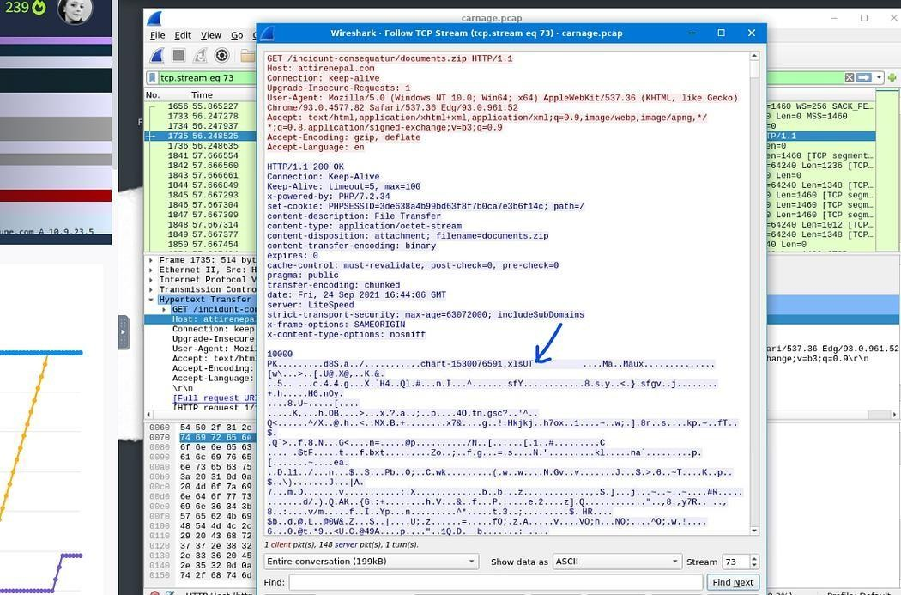

  - What is the name of the webserver of the malicious IP from which the zip file was downloaded?
LiteSpeed

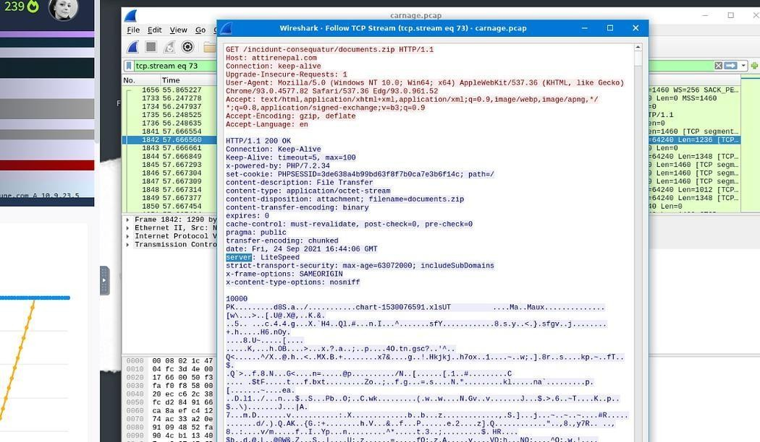
Got the answer in the screen we used in 2.4. Press enter or click to view image in full size

  - What is the version of the webserver from the previous question?
1.6. PHP/7.2.34

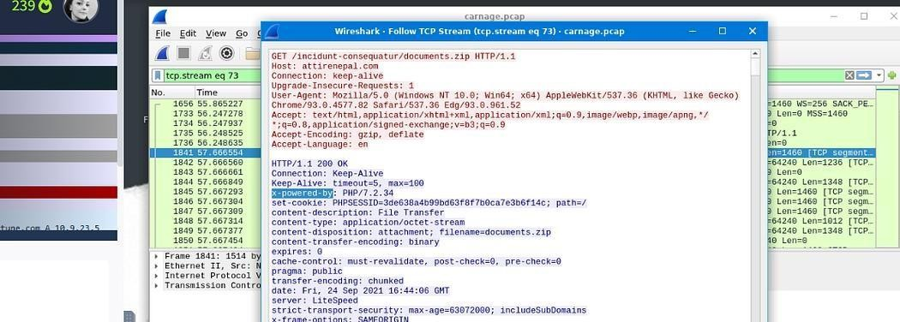
Got the answer in the screen we used in 2.4. Press enter or click to view image in full size

  - Malicious files were downloaded to the victim host from multiple domains. What were the three domains involved with this activity?
finejewels.comau,thietbiagt.com, new.americold.com

Cleared the previous filter. Applied dns as display filter.

The room provides a hint: check HTTPS traffic. Narrow down the timeframe from 16:45:11 to 16:45:30.

Updated the filter as shown below
dns&&(frame.time >= “2021–09–24 16:45:11” && frame.time <= “2021–09–
24 16:45:30”)

Press enter or click to view image in full size
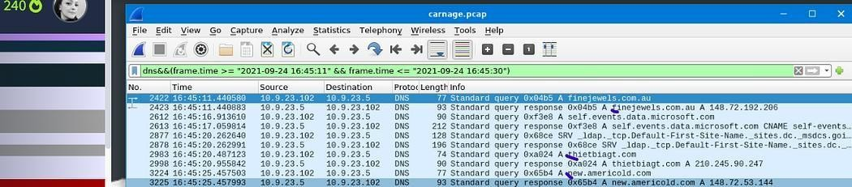

  - Which certificate authority issued the SSL certificate to the first domain from the previous question?
GoDaddy

Press enter or click to view image in full size
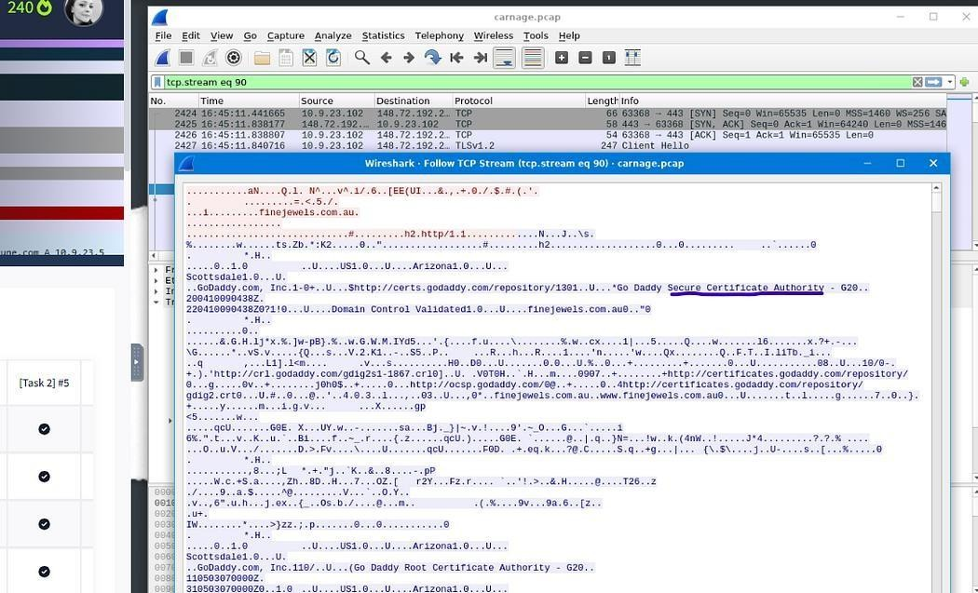

  - What are the two IP addresses of the Cobalt Strike servers? Use VirusTotal (the Community tab) to confirm if IPs are identified as Cobalt Strike

C2 servers. (answer format: enter the IP addresses in sequential order)
185.106.96.158, 185.125.204.174

In the main menu bar clicked Statistics, then Conversations. Chose TCP. Ordered results by column Packets.
Press enter or click to view image in full size
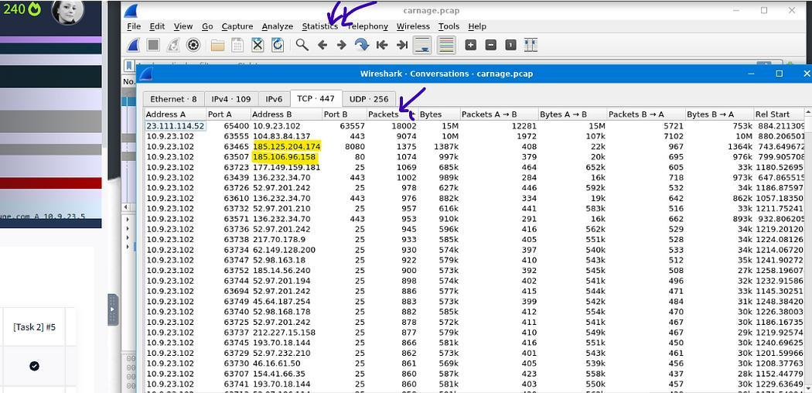

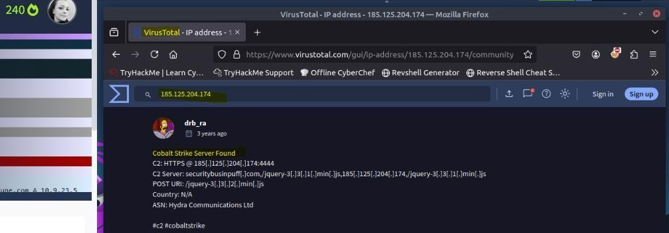
Researched in VirtusTotal and confirmed that it is about Cobalt Strike. Press enter or click to view image in full size

  - What is the Host header for the first Cobalt Strike IP address from the previous question?
ocsp.verisign.com

Used filter ip.addr == 185.106.96.158
Searched for GET.
Press enter or click to view image in full size

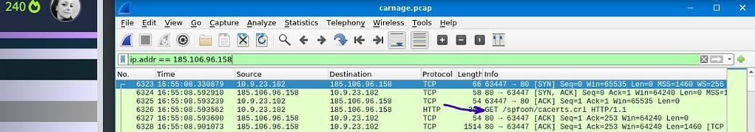

Followed its HTTP Stream.

Press enter or click to view image in full size
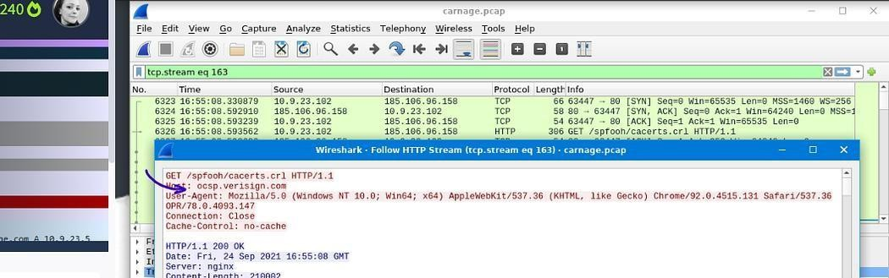

  - What is the domain name for the first IP address of the Cobalt Strike server? You may use VirusTotal to confirm if it’s the Cobalt Strike server (check the Community tab).
survmeter.live

It was provided a hint: Filter out for dns queries. Applied filter: dns.a == 185.106.96.158
Press enter or click to view image in full size
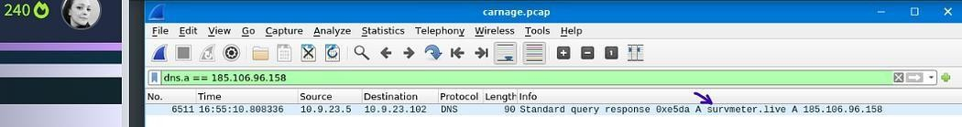

Could also read the information provided in VirtusTotal. Press enter or click to view image in full size



  - What is the domain name of the second Cobalt Strike server IP? You may use VirusTotal to confirm if it’s the Cobalt Strike server (check the Community tab).
securitybusinpuff.com

Applied filter: dns.a == 185.125.204.174

Press enter or click to view image in full size
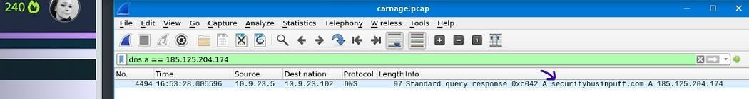


Could also read the information provided in VirtusTotal. Press enter or click to view image in full size

  - What is the domain name of the post-infection traffic?
maldivehost.net

It was provided a hint: Filter POST HTTP traffic. Applied filter: http.request.method = “POST”.
Press enter or click to view image in full size
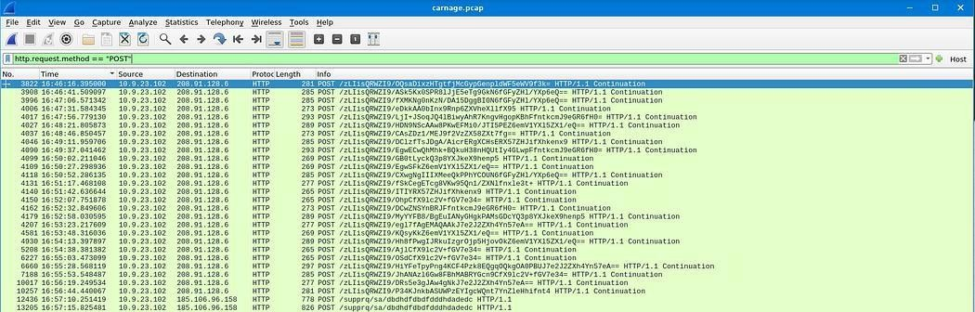

Followed HTTP Stream.

Press enter or click to view image in full size
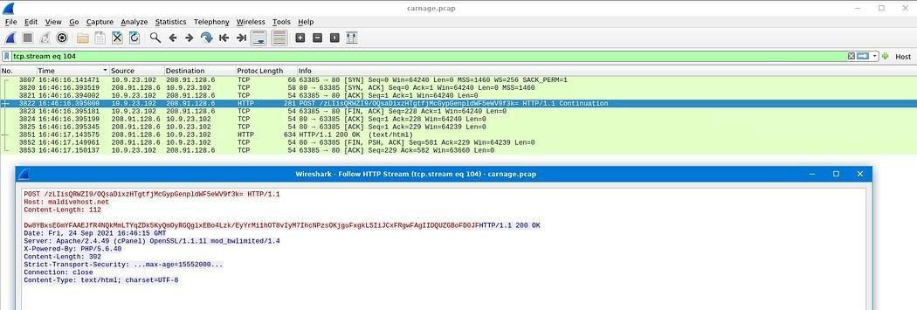

  - What are the first eleven characters that the victim host sends out to the malicious domain involved in the post-infection traffic?
LIisQRWZI9

Applied filter: http.host == maldivehost.net.

Press enter or click to view image in full size
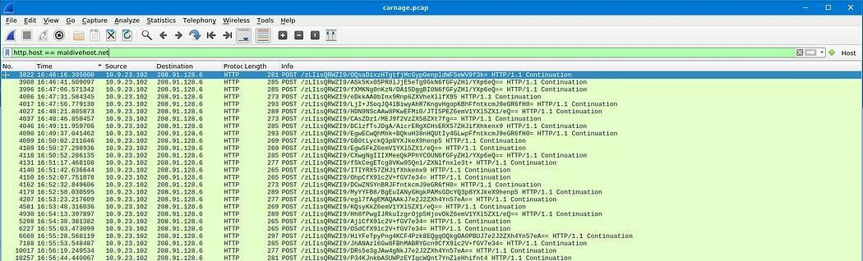

Followed HTTP Stream.
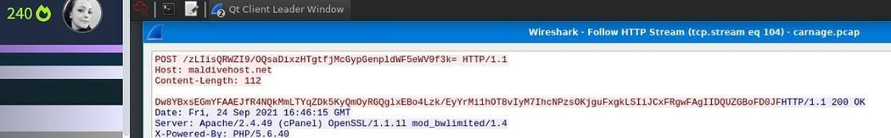
Could have just analyzed HTTP Stream followed in 2.13. Press enter or click to view image in full size

  - What was the length for the first packet sent out to the C2 server?
281

Applied filter: http.request.method = “POST”.
Looked for Length field.

Press enter or click to view image in full size
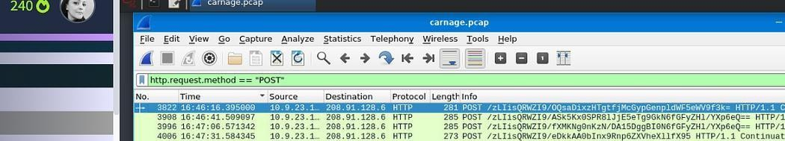

  - What was the Server header for the malicious domain from the previous question?
Apache/2.4.49 (cPanel) OpenSSL/1.1.1l mod_bwlimited/1.4

The answer is direct looking into 2.14.

  - The malware used an API to check for the IP address of the victim’s machine. What was the date and time when the DNS query for the IP check domain occurred? (answer format: yyyy-mm-dd hh:mm:ss UTC)
Apache/2.4.49 (cPanel) OpenSSL/1.1.1l mod_bwlimited/1.4

Our victim´s machine is 10.9.23.102 .
Applied filter: ip.addr==10.9.23.102 && dns && frame contains “api”

Press enter or click to view image in full size

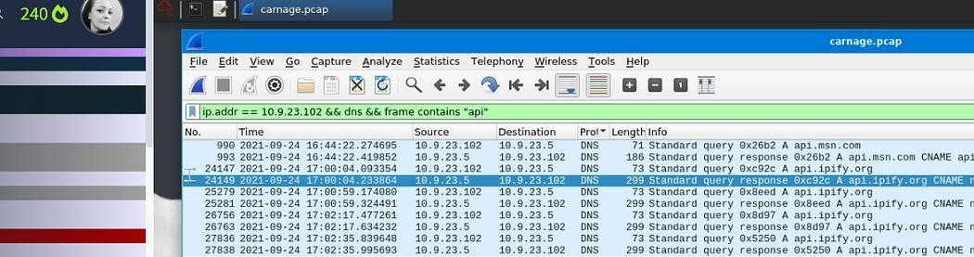

  - What was the domain in the DNS query from the previous question?
api.ipify.org

Followed UDP Stream related to 2.17.

Press enter or click to view image in full size
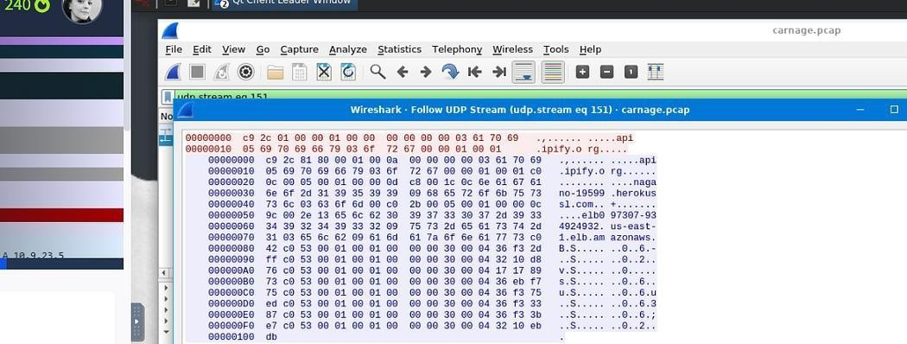

  - Looks like there was some malicious spam (malspam) activity going on. What was the first MAIL FROM address observed in the traffic?
farshin@mailfa.com

Applied filter: smtp.req.parameter contains “FROM”

Press enter or click to view image in full size
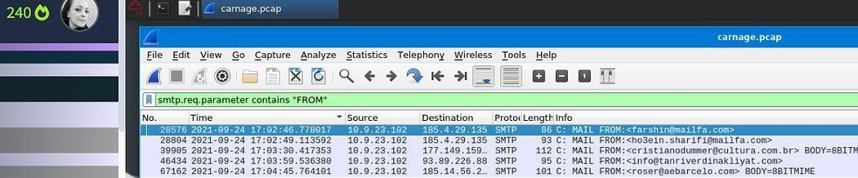

  - How many packets were observed for the SMTP traffic?
1439

Press enter or click to view image in full size
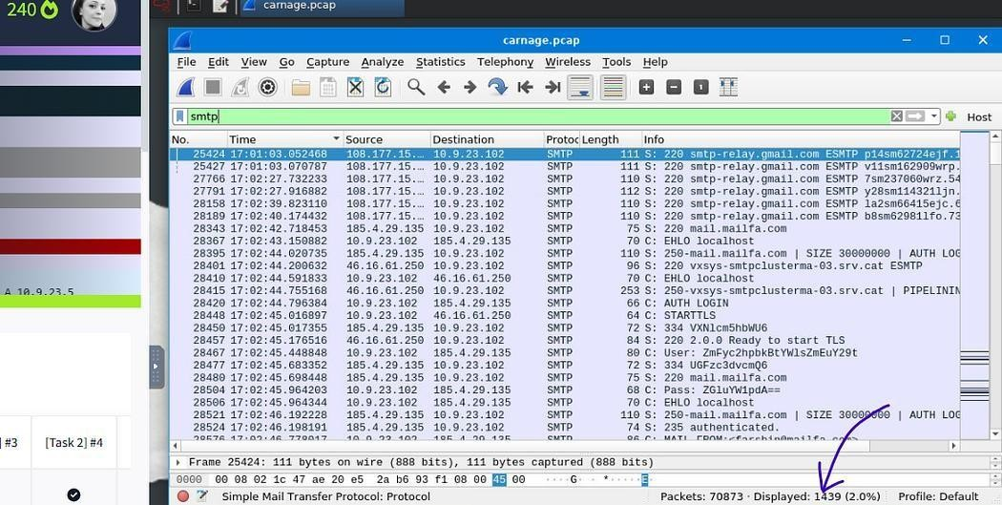

Employed another method to find the answer which was:
- Clicked Statistics in the main menu bar.
- Clicked IPv4 Statistics.
- Clicked IP Protocol Types.
- Typed smtp in Display filter: field.
- Clicked Apply.

Press enter or click to view image in full size
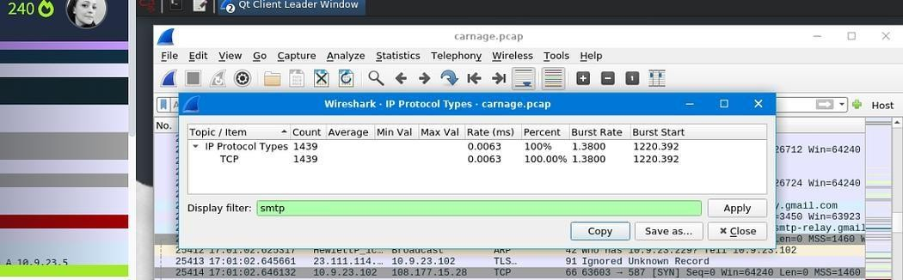

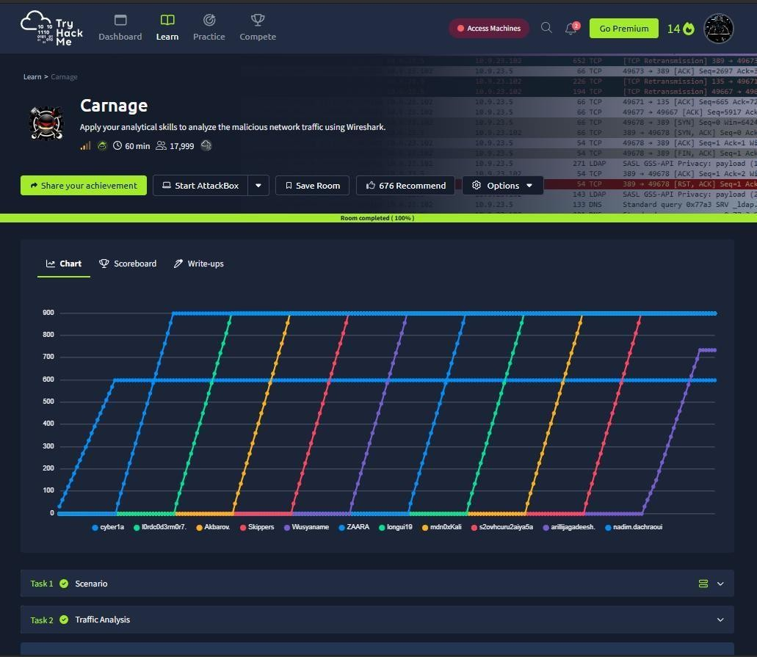

Result:

Successfully identified malicious domains, downloaded payloads, Cobalt Strike C2 servers, post-infection traffic, SMTP malspam activity, and indicators of compromise (IOCs).

